Naive Bayes Example
Let’s take a dataset to predict whether we can pet an animal or not.
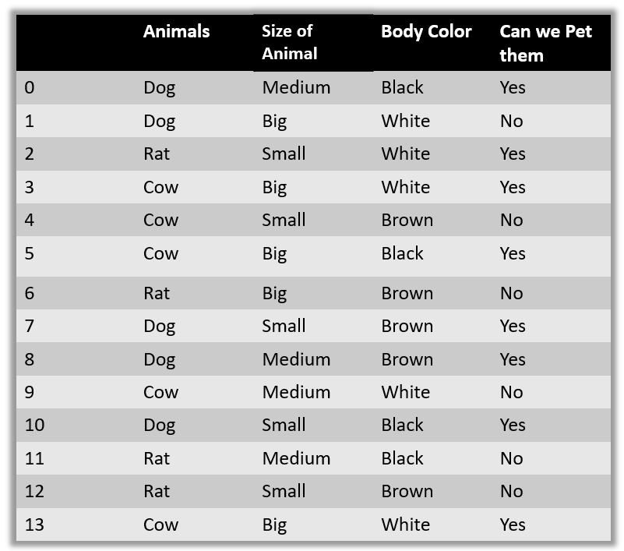

Assumptions of Naive Bayes
· All the variables are independent. That is if the animal is Dog that doesn’t mean that Size will be Medium
· All the predictors have an equal effect on the outcome. That is, the animal being dog does not have more importance in deciding If we can pet him or not. All the features have equal importance.
We should try to apply the Naive Bayes formula on the above dataset however before that, we need to do some precomputations on our dataset.
We need to find P(x_{i}|y_{j}) for each x_{i} in X and each y_{j} in Y. All these calculations have been demonstrated below:
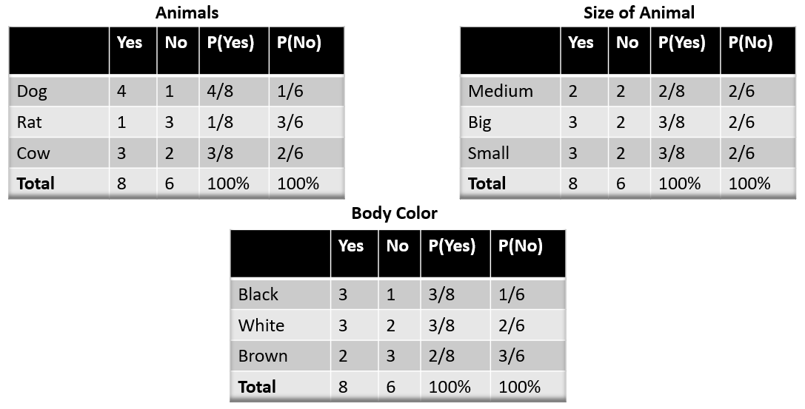

We also need the probabilities (P(y)), which are calculated in the table below. For example, P(Pet Animal = NO) = 6/14.
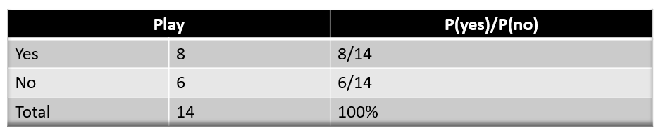
Now if we send our test data, suppose test = (Cow, Medium, Black)
Probability of petting an animal :
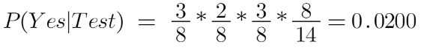
And the probability of not petting an animal:
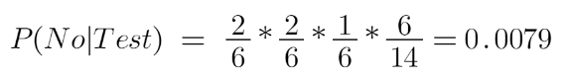
We know P(Yes|Test)+P(No|test) = 1
So, we will normalize the result:
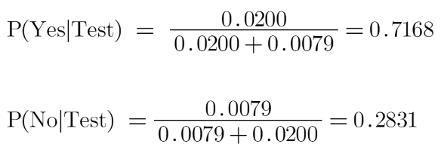
We see here that P(Yes|Test) > P(No|Test), so the prediction that we can pet this animal is “Yes”.
Gaussian Naive Bayes (GNB) is a variant of the Naive Bayes algorithm, a simple yet powerful classification algorithm. It's particularly useful when dealing with continuous data, where the features are assumed to follow a Gaussian (normal) distribution.

Here's how it works:

1. **Assumption of Independence**: Like other Naive Bayes classifiers, GNB assumes that features are conditionally independent given the class label. In other words, the presence of a particular feature in a class is unrelated to the presence of any other feature.

2. **Modeling Feature Distributions**: GNB models the distribution of each class's features using a Gaussian distribution (hence the name "Gaussian"). It estimates the mean and variance of each feature for each class.

3. **Bayesian Classification**: Given a new instance with feature values, GNB calculates the probability of the instance belonging to each class using Bayes' theorem. It selects the class with the highest probability as the predicted class for the instance.

4. **Mathematical Formulation**: The probability density function (PDF) of a Gaussian distribution is used to compute the likelihood of each feature value given the class. The class priors (prior probabilities of each class) are also incorporated into the calculation.

5. **Decision Rule**: The class with the highest posterior probability (computed using Bayes' theorem) is chosen as the predicted class.

Despite its simplicity and the strong assumptions it makes, Gaussian Naive Bayes often performs surprisingly well in practice, especially on datasets where the independence assumption holds reasonably well and the features have approximately Gaussian distributions. However, it may not perform well if the data violates these assumptions significantly.
Multinomial Naive Bayes (MNB) is another variant of the Naive Bayes algorithm, specifically designed for text classification tasks where the features represent the frequencies of words or other tokens. It's particularly useful when dealing with data represented as counts, such as word counts in document classification or term frequency-inverse document frequency (TF-IDF) vectors.

Here's how it works:

1. **Feature Representation**: MNB assumes that the features represent the counts of each term or word occurring in a document. It's commonly used in text classification tasks where the input features are represented as word counts or TF-IDF values.

2. **Probability Estimation**: MNB estimates the probability of each term occurring in each class using the training data. It calculates the conditional probability of each term given the class, typically using a smoothed version of the maximum likelihood estimation to handle unseen terms.

3. **Independence Assumption**: Like other Naive Bayes classifiers, MNB assumes that features are conditionally independent given the class label. In the context of text classification, this means that the presence of each term in a document is independent of the presence of other terms, given the document's class.

4. **Classification**: Given a new document represented as term frequencies or TF-IDF values, MNB calculates the probability of the document belonging to each class using Bayes' theorem. It selects the class with the highest probability as the predicted class for the document.

5. **Laplace Smoothing**: To handle the issue of zero probabilities for terms not present in the training data, MNB often applies Laplace smoothing or other smoothing techniques to the probability estimation.
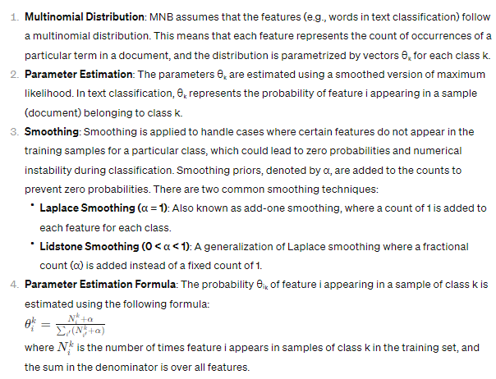

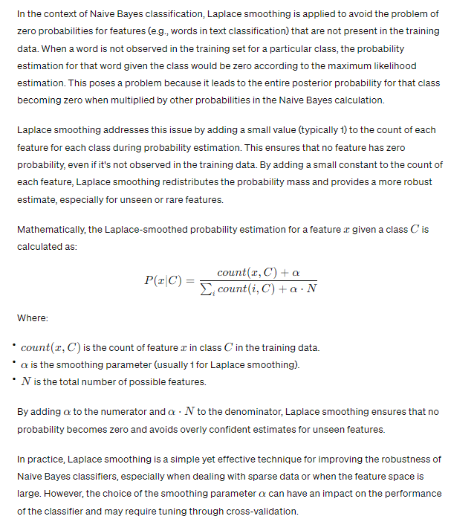

CountVectorizer is a feature extraction technique used in natural language processing (NLP) for converting a collection of text documents into a matrix of token counts. Each row of the matrix represents a document, and each column represents a unique word in the corpus, with each cell representing the frequency of a word in a particular document.
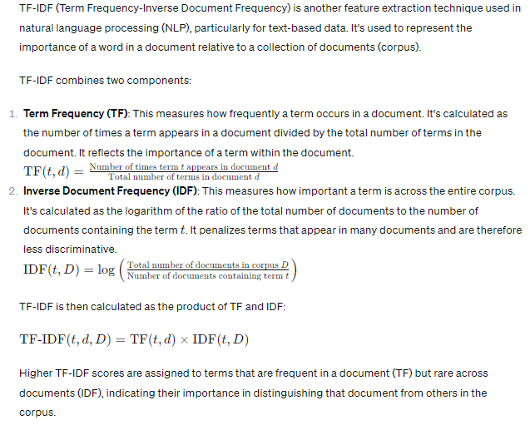
Determining whether CountVectorizer or TF-IDFVectorizer (TfidfVectorizer) is better depends on the specific task, the characteristics of the dataset, and the goals of the analysis. Here's a comparison of the two techniques:

**CountVectorizer:**
- **Pros:**
- Simple to understand and implement.
- Captures the frequency of words in documents.
- Retains some information about the importance of words within documents.
- **Cons:**
- Ignores the relative importance of words across documents.
- Treats all words equally, regardless of their uniqueness or informativeness.

**TF-IDFVectorizer (TfidfVectorizer):**
- **Pros:**
- Considers both the frequency of words in documents (TF) and their importance across the entire corpus (IDF).
- Penalizes common words that occur frequently across documents, giving more weight to rare words that are more discriminative.
- Can improve the performance of text classification algorithms by focusing on the most informative words.
- **Cons:**
- More complex than CountVectorizer.
- May require tuning of parameters such as `smooth_idf`, `sublinear_tf`, and `norm` for optimal performance.
- May not perform well if the dataset is small or if the document lengths are highly variable.

**Which one to choose:**
- **Use CountVectorizer if:**
- The relative importance of words across documents is not critical for your task.
- You want a simple and computationally efficient method for feature extraction.
- You're working with a small dataset or a dataset with consistent document lengths.

- **Use TF-IDFVectorizer (TfidfVectorizer) if:**
- You want to capture the relative importance of words across documents.
- You're working with a large dataset or a dataset with highly variable document lengths.
- You're building a text classification or clustering model where discriminative features are important.
- You're willing to spend more computational resources for potentially better performance.
In many cases, TF-IDFVectorizer tends to perform better than CountVectorizer, especially in tasks such as text classification, information retrieval, and clustering. However, it's always a good idea to experiment with both techniques and choose the one that performs best for your specific task and dataset.
Complement Naive Bayes (CNB) is an adaptation of the standard Naive Bayes algorithm, specifically designed to address the issue of imbalanced datasets, where one class is more frequent than the others. It was introduced by Rennie et al. in 2003 as a modification of the multinomial Naive Bayes (MNB) classifier.
Here's an overview of how Complement Naive Bayes works:

1. **Similarity with Multinomial Naive Bayes (MNB)**: Like MNB, CNB is designed for text classification tasks where features represent word counts or TF-IDF values.

2. **Complement Class Model**: In CNB, instead of modeling the probability of each class independently, it models the complement of the class. This means it models the distribution of features in the complementary class for each class. For example, if class A has a high frequency of the word "cat," the complement class for class A would have a low frequency of "cat."

3. **Frequency-based Weighting**: CNB assigns weights to features based on their frequencies in the complement class. Features that occur frequently in the complement class of a particular class are given lower weights, while features that occur less frequently are given higher weights.

4. **Weighted Naive Bayes Classification**: CNB uses the weighted features to calculate class probabilities using the Naive Bayes formula. It calculates the likelihood of each feature given the class using the complement class model and combines them using Bayes' theorem to compute the class probabilities.

5. **Balancing Effect**: By modeling the complement class, CNB effectively balances the contribution of each class to the classification decision, making it more robust to class imbalances compared to standard Naive Bayes algorithms.
Bernoulli Naive Bayes (BNB) is another variant of the Naive Bayes algorithm, similar to Multinomial Naive Bayes (MNB), but specifically designed for binary feature vectors. It's commonly used in text classification tasks where the features represent whether or not a term occurs in a document (binary presence or absence), rather than the frequency of occurrence.

Here's how Bernoulli Naive Bayes works:

1. **Feature Representation**: BNB assumes that the features are binary, indicating the presence or absence of each term in the document. It's typically used with binary feature vectors derived from text data, where each feature represents the presence (1) or absence (0) of a term in the document.

2. **Bernoulli Distribution**: BNB models the likelihood of each feature given the class using the Bernoulli distribution, which is appropriate for binary data. It estimates the probability of each term occurring (or not occurring) in a document for each class.

3. **Independence Assumption**: Like other Naive Bayes classifiers, BNB assumes that features are conditionally independent given the class label. In the context of text classification, this means that the presence or absence of each term in a document is independent of the presence or absence of other terms, given the document's class.

4. **Classification**: Given a new document represented as a binary feature vector, BNB calculates the probability of the document belonging to each class using Bayes' theorem. It selects the class with the highest probability as the predicted class for the document.

5. **Smoothing**: BNB may apply Laplace smoothing or other smoothing techniques to handle the issue of zero probabilities for features that are not observed in the training data.
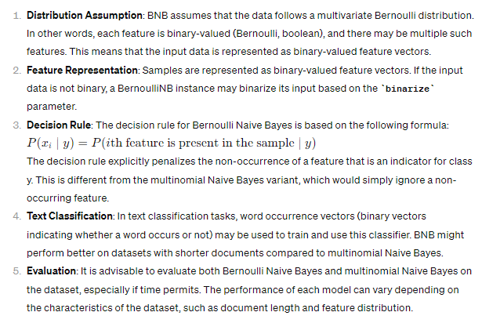
Categorical Naive Bayes (CatNB) is a variant of the Naive Bayes algorithm that is designed specifically for categorical features. Unlike Gaussian Naive Bayes (GNB) which assumes continuous features following a Gaussian distribution, and Multinomial Naive Bayes (MNB) which is suitable for discrete features representing counts, Categorical Naive Bayes is used when dealing with features that are categorical in nature.

Here's how Categorical Naive Bayes works:

1. **Feature Representation**: CatNB assumes that the features are categorical, meaning they belong to discrete categories rather than continuous values. These categories could represent various attributes or properties of the data.

2. **Categorical Distribution**: CatNB models the likelihood of each feature given the class using the categorical distribution. This distribution is suitable for modeling categorical data, where each feature can take on one of a fixed set of discrete values.

3. **Independence Assumption**: Similar to other Naive Bayes classifiers, CatNB assumes that features are conditionally independent given the class label. This means that the presence or absence of each category of a feature is independent of the presence or absence of other categories, given the class.

4. **Classification**: Given a new instance represented by categorical features, CatNB calculates the probability of the instance belonging to each class using Bayes' theorem. It selects the class with the highest probability as the predicted class for the instance.

5. **Smoothing**: CatNB may apply smoothing techniques to handle the issue of zero probabilities for categories that are not observed in the training data. Laplace smoothing or other smoothing methods can be employed to ensure non-zero probabilities for all categories.
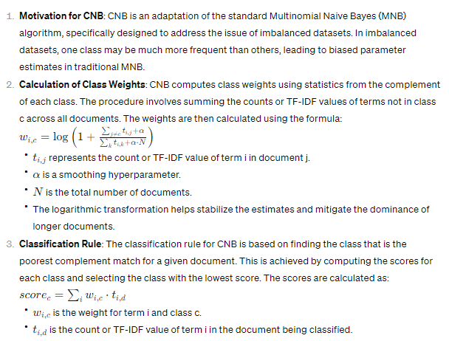
Out-of-core learning is a technique used to train machine learning models on datasets that are too large to fit into memory. Naive Bayes algorithms are particularly well-suited to this approach because they have relatively low memory requirements and can be updated incrementally as new data becomes available.

